LAB Assignment-4

- Create the following tables with the constraints mentioned:
Note: the data type and size should be give in relevance with the data to
be inserted. Constraint name are not required to be given for this assignment.
Customer Movie
Cust_id | Fname | Lname | Area | Phone |  | Mv_no | Cust_id | Title | Star | Price
Primary Key | Not Null |  | Not Null |  |  | Primary Key | Foreign  Key | Not Null | Not Null | Should be between 100 and 250
A01 | Ivan | Ross | SA | 6125467 |  | 1 | A02 | Bloody | JC | 181
A02 | Vandana | Ray | MU | 5560379 |  | 2 | A04 | The Firm | TC | 200
A03 | Pramada | Jauguste | DA | 4560389 |  | 3 | A01 | Pretty Woman | RG | 151
A04 | Basu | Navindi | BA | 6125401 |  | 4 | A06 | Home Alone | MC | 150
A05 | Ravi | Shridhar | NA | null |  | 5 | A05 | The Fugitive | MF | 200
A06 | Rukmini | Aiyer | GH | 5125274 |  | 6 | A03 | Coma | MD | 100
 |  |  |  |  |  | 7 | A02 | Dracula | GO | 150
 |  |  |  |  |  | 8 | A06 | Quick Change | BM | 100
 |  |  |  |  |  | 9 | A03 | Gone with the Wind | CB | 200
 |  |  |  |  |  | 10 | A05 | Carry on Doctor | LP | 100

QUERY: CREATE TABLE Customer(Cust_id Varchar(3) PRIMARY KEY, Fname VARCHAR(20) NOT NULL, Lname VARCHAR(15), Area VARCHAR(10) NOT NULL, Phone VARCHAR(10));
CREATE TABLE Movie(Mv_no int(3) PRIMARY KEY, Cust_id VARCHAR(3), Title VARCHAR(15) NOT NULL, Star VARCHAR(5) NOT NULL, Price INT(3) CHECK(Price BETWEEN 100 AND 250), FOREIGN KEY(Cust_id) REFERENCES Customer(Cust_id));
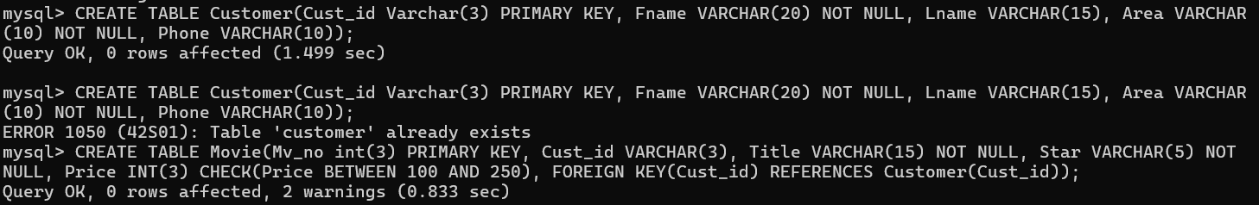
- Prove that entity integrity constraint is ensured by both the tables. (2 conditions to be checked).
QUERY: Customer table
SELECT * FROM Customer WHERE Cust_id IS NULL;

Movie table
SELECT * FROM Movie WHERE Mv_no IS NULL;

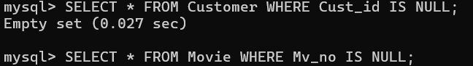

Customer table
SELECT Cust_id, COUNT(*)
FROM Customer
GROUP BY Cust_id
HAVING COUNT(*) > 1;

Movie table
SELECT Mv_no, COUNT(*)
FROM Movie
GROUP BY Mv_no
HAVING COUNT(*) > 1;

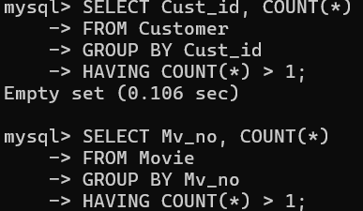

- Prove that referential integrity constraint is ensured by both the tables.
QUERY: SELECT Cust_id
FROM Movie
WHERE Cust_id NOT IN (SELECT Cust_id FROM Customer);

- Prove that domain integrity constraint is ensured by the Movie table.
QUERY: SELECT *
FROM Movie
WHERE Price < 100 OR Price > 250;
- Display the movie titles, whose price is greater than 100 but less than 200.
QUERY: SELECT Title FROM Movie WHERE Price BETWEEN 100 AND 200;

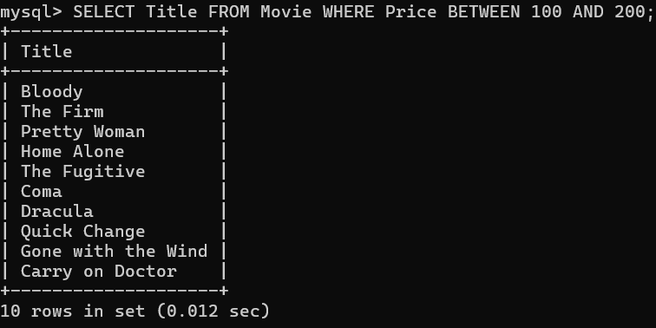

- Display the cust_id who have seen movies having stars as either JC or TC or MC.
QUERY: SELCT Cust_id FROM Movie WHERE Star IN (‘JC’,’TC’,’MC’);

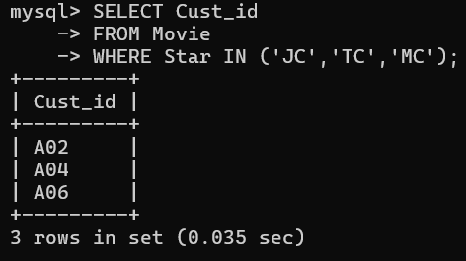

- Display the details of those customers who have an A in their area name.
QUERY: SELECT * FROM Customer WHERE Area LIKE ‘%A%;

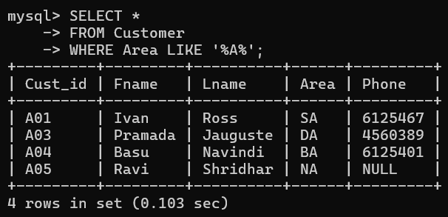

- Display the movie titles, whose price is within 180 and the movie titles are of exactly 6 characters.
QUERY: SELECT Title FROM MOVIES WHERE Price<=180 AND LENGTH(Title)=6;

- Display the movie name, their original prices and the prices after 10% increment. Give alias name to the incremented price column.
QUERY: SELECT Title, Price, (Price + Price * 0.1) AS Incremented_Price FROM MOVIE;

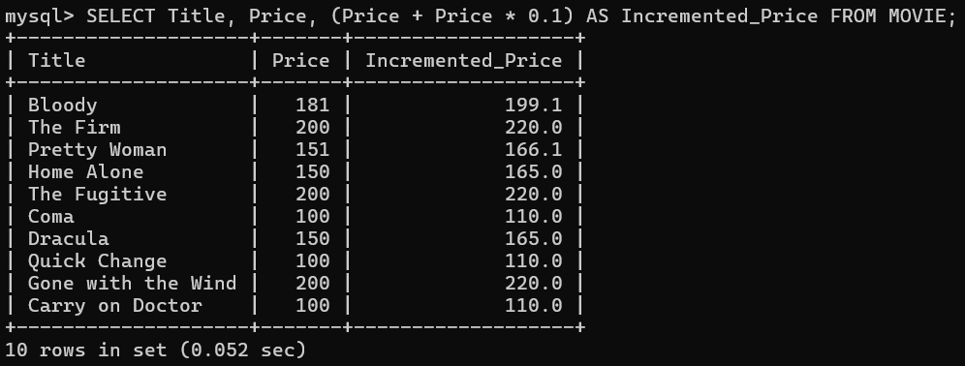

- Display all the customer details in the following way:
‘Ivan Ross stays in SA and his phone number is 6125467.’
QUERY: SELECT CONCAT(Fname, ‘ ’, Lname, ‘ stays in ’, Area, ‘and his phone number is ’, Phone) FROM Customer;
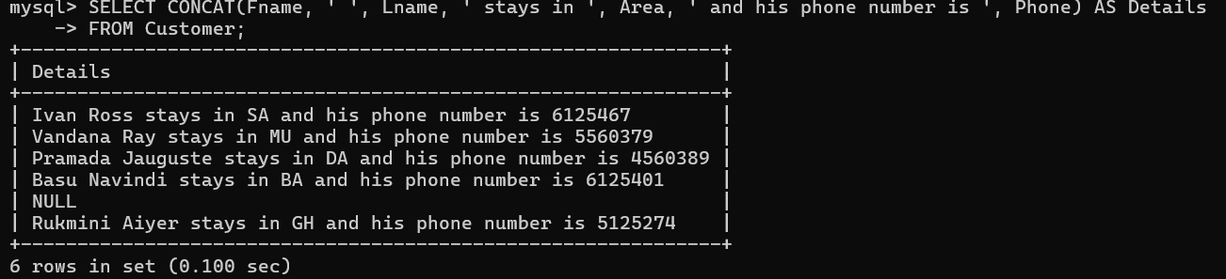

- Add a not null constraint to the Lname field in Customer.
QUERY: ALTER TABLE Customer MODIFY Lname Varchar(20) NOT NULL;

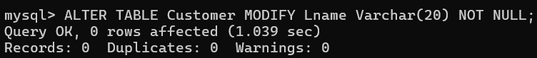

- Display the customer name whose phone number is not recorded.
QUERY: SELECT Concat(Fname, Lname) AS DETAILS WHERE PHONE IS NULL;

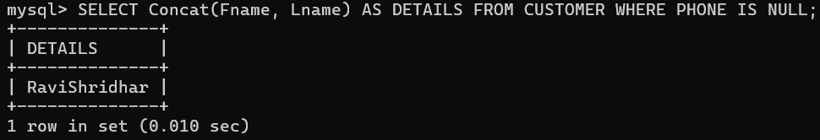

- Add the phone number according to your own wish for the person mentioned in problem no 7.
QUERY: UPDATE CUSTOMER SET PHONE = 7295047 WHERE Cust_id = ‘A05’;

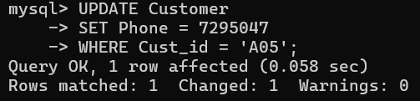

- Display the unique customer id’s from movie table.
QUERY: SELECT DISTINCT(Cust_id) FROM MOVIE;

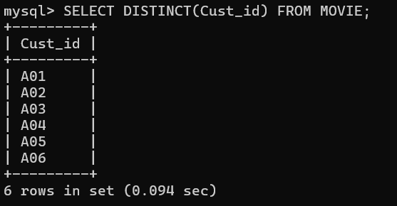

- Remove the not null constraint from Star column in movie table.
QUERY: ALTER TABLE MOVIE MODIFY Star VARCHAR(5);

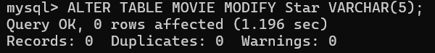

- Delete any row from the Customer table. If you cannot delete, then note the error message displayed.
QUERY: DELETE FROM Customer WHERE Cust_id = 'A01';

- Delete any row from the Movie table. If you cannot delete, then note the error message displayed.
QUERY: DELETE FROM Movie WHERE Mv_no = 1;

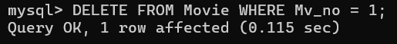

- Drop the Customer table. If you cannot drop, then note the error message displayed.
QUERY: DROP TABLE Customer;

- Drop the Movie table. If you cannot drop, then note the error message displayed.
QUERY: DROP TABLE Movie;



- Drop the foreign key from Movie table.
QUERY: ALTER TABLE Movie DROP FOREIGN KEY Cust_id;

